Research Paper: Autism

Miranda Palacio

CSS-43
Jenny Donegan
March 20, 2012

Table of Contents
- Autism Description
- History of Autism
- Symptoms of Autism
- Diagnosis of Autism
- Cures or treatment for Autism
- Autism Statistics
- Conclusion
- Work Cited

- Autism Description
Autism is defined by the Autism Society of America (ASA) as: "Autism is a complex developmental disability that typically appears during the first three years of life and is the result of a neurological disorder that affects the normal functioning of the brain, impacting development in the areas of social interaction and communication skills. Both children and adults with autism typically show difficulties in verbal and non-verbal communication, social interactions, and leisure or play activities.”
Autism is four more times prevalent in boys than girls. Autism shows no racial, ethnic or social boundaries. Family income, lifestyle and educational levels do not affect the chance of autism's occurrence. Autism and its associated behaviors have been estimated to occur in as many and one in 500 individuals.
- History of Autism
The word "autism," which has been in use for about 100 years, comes from the Greek word "autos," meaning "self." The term describes conditions in which a person is removed from social interaction -- hence, an isolated self.
Autism was first described in 1943 by Johns Hopkins University psychiatrist Leo Kanner, who worked with 11 self-absorbed children with severe social, communication and behavioral problems. Kanner suggested the social difficulties lay in the children's inability to form emotional attachments with their parents.(Glazer)
Early on, autism was considered one of several psychotic disorders related to schizophrenia. Blame was often placed on parents, most notably, the supposedly cold mother described by Bettelheim. Until the 1970s, Freudian-based therapy, such as that used at Bettelheim's psychoanalytically based Orthogenic School for autistic children in Chicago, was dominant.(Glazer)
Today, many experts believe autism research was actually hampered by these approaches. Moreover, “there was no empirical literature from psychodynamic interventions showing real change in people with autism,” notes Sally J. Rogers, a professor of psychiatry at the M.I.N.D. Institute.
More recent research has associated autism with structural abnormalities in the brain. Autopsy studies of the brains of a handful of autistic individuals have revealed enlarged brain size among autistic adults. In addition, unusually small, densely packed cells have been found in the brain's limbic system, which is important for learning, memory, emotion and behavior.
- Symptoms of Autism
Children with autism generally have problems in three crucial areas of development — social interaction, language and behavior. But because autism symptoms vary greatly, two children with the same diagnosis may act quite differently and have strikingly different skills. In most cases, though, severe autism is marked by a complete inability to communicate or interact with other people.(WebMD)
Some children show signs of autism in early infancy. Other children may develop normally for the first few months or years of life but then suddenly become withdrawn, become aggressive or lose language skills they've already acquired.
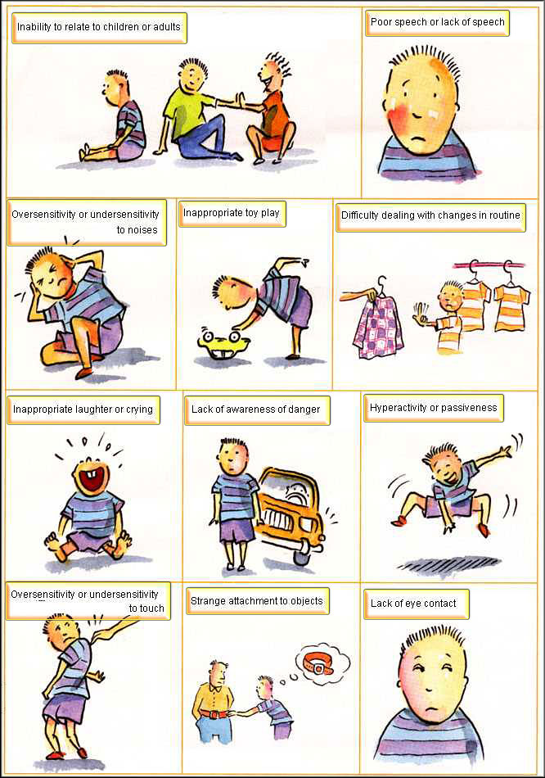
http://www.disabilitynews.org/wp-content/uploads/2009/04/autism_syptoms.jpg
- Diagnosis of Autism
Presently, we don’t have a medical test that can diagnose autism. Instead, specially trained physicians and psychologists administer autism-specific behavioral evaluations. From birth to at least 36 months of age, every child should be screened for developmental milestones during routine well visits. When such a screening—or a parent—raises concerns about a child's development, the doctor should refer the child to a specialist in developmental evaluation and early intervention. These evaluations should include hearing and lead exposure tests as well as an autism-specific screening tool such as the M-CHAT. Among these screening tools are several geared to older children and/or specific autism spectrum disorders.(Autism Speaks)
A typical diagnostic evaluation involves a multi-disciplinary team of doctors including a pediatrician, psychologist, speech and language pathologist and occupational therapist. Genetic testing may likewise be recommended, as well as screening for related medical issues such as sleep difficulties.
- Cure or Treatment for Autism
There is no cure for autism; however, with appropriate treatment and education, many children with the disorder can learn and develop. Early intervention often can reduce challenges associated with the disorder, lessen disruptive behavior, and provide some degree of independence.
Treatment depends on the individual needs of the patient. In most cases, a combination of treatment methods is more effective. Autism usually requires lifelong treatment. Autism treatments include behavior modification, communication therapy, dietary modification, and medication. (Autism Speaks)
- Autism Statistics
Autism statistics from the U.S. Centers for Disease Control and Prevention (CDC) identify around 1 in 110 American children as on the autism spectrum–a 600 percent increase in prevalence over the past two decades. Careful research shows that this increase is only partly explained by improved diagnosis and awareness. Studies also show that autism is three to four times more common among boys than girls. An estimated 1 out of 70 boys is diagnosed with autism in the United States.
More children will be diagnosed with autism this year than with childhood cancer, juvenile diabetes or pediatric AIDS combined. ASD affects an estimated 3 million individuals in the U.S. and tens of millions worldwide. Moreover, government autism statistics suggest that prevalence rates have increased 10 to 17 percent annually in recent years. There is no established explanation for this continuing increase, although improved diagnosis and environmental influences are two reasons often considered.(CDC)
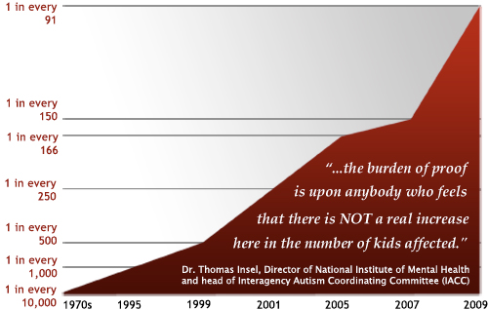
- Conclusion
The reason I choose to do my research paper on Autism is because I would always see commercials on television about it, but I never understood what it was or how a child would get it. The most interesting thing I learned while doing this project is that there is no cure and statistics show that more and more children are being diagnosed with this disease every year. The most important source that I used was Autism Speaks and WebMD. The question that I still have about this disease is how children get it but sadly they haven’t figured that out yet. I feel like the strengths from my report are the strong supporting information I was able to gather, and my weakness would be that I had a hard time finding recent diagrams.

- Work Cited
Glazer, S. (2003, June 13). Increase in autism. CQ Researcher, 13, 545-568. Retrieved from http://library.cqpress.com/cqresearcher/
"Autism - Symptoms." WebMD. Better information Better health. WebMD, 12 Apr. 2010. Web. 20 Mar. 2012. <http://www.webmd.com/brain/autism/autism-symptoms>.
"How Is Autism Diagnosed?." Autism Speaks. It's time to listen. Autism Speaks Inc., 2011. Web. 20 Mar. 2012. <http://www.autismspeaks.org/what-autism/diagnosis>.
"How Is Autism Treated?." Autism Speaks. It's time to listen. Autism Speaks Inc., 2011. Web. 20 Mar. 2012. <http://www.autismspeaks.org/what-autism/treatment>.
"Autism Spectrum Disorders (ASDs)." CDC. Centers for Disease Control and Prevention, 13 May 2010. Web. 20 Mar. 2012. <http://www.cdc.gov/ncbddd/autism/data.html>.

